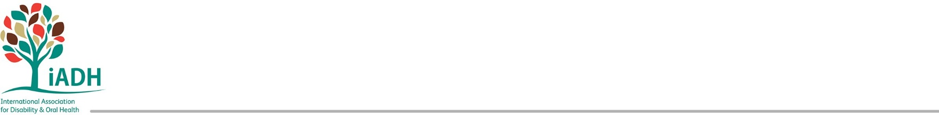
Call for Interest-

w w w . i a d h . o r g

President Elect of iADH

iADH is looking for a dynamic motivated President Elect to assist the President in general supervision of the affairs of the Corporation and move into the role of the iADH President in 2028. The President Elect will assist the President in implementing the strategic plans 2026-2028 to promote the iADH mission.

President-Elect– If appointed, the President Elect will assist the President as the chief executive officer of the Corporation. The President Elect will assist the President in implementing the strategic plans and policies of the Corporation.

Applications are welcome from within the current iADH Council and Committees for a candidate with proven previous experience in a similar role.
The successful applicants will work alongside the current key stakeholders:
- iADH President and Executive Committee
- iADH Education Committee
- iADH Scientific Committee
- iADH International Advisory Committee
- iADH Media Committee
- iADH Council Members
- iADH Board
- iADH Congress Local Organizing Committee

Please consider your willingness and ability to attend regular online meetings, occasionally during unsociable or work hours depending on time zones involved within an international committee structure.

APPLICATION PROCESS:

Please send your application to secretary@iadh.org by Monday 1st June 2026.

Please include your iADH membership number, a short CV (max 2 pages) and a cover letter (max 1000 words) stating your reason for interest in being the President-Elect of the executive committee and evidence of previous experience in similar roles. Your application must be supported by two named current iADH members of good standing.


All applications will be considered by the iADH Nominations Committee and their recommendations will be presented to the executive.

